PUBLICATION OF THE ASSOCIATED LOCKSMITHS OF AMERICA, INC

If: THE OFFICIAL INTERNATIONAL

***Volume 46, Issue 2***

***February 2000***

Election Information and Petitions are on pages 14-15!

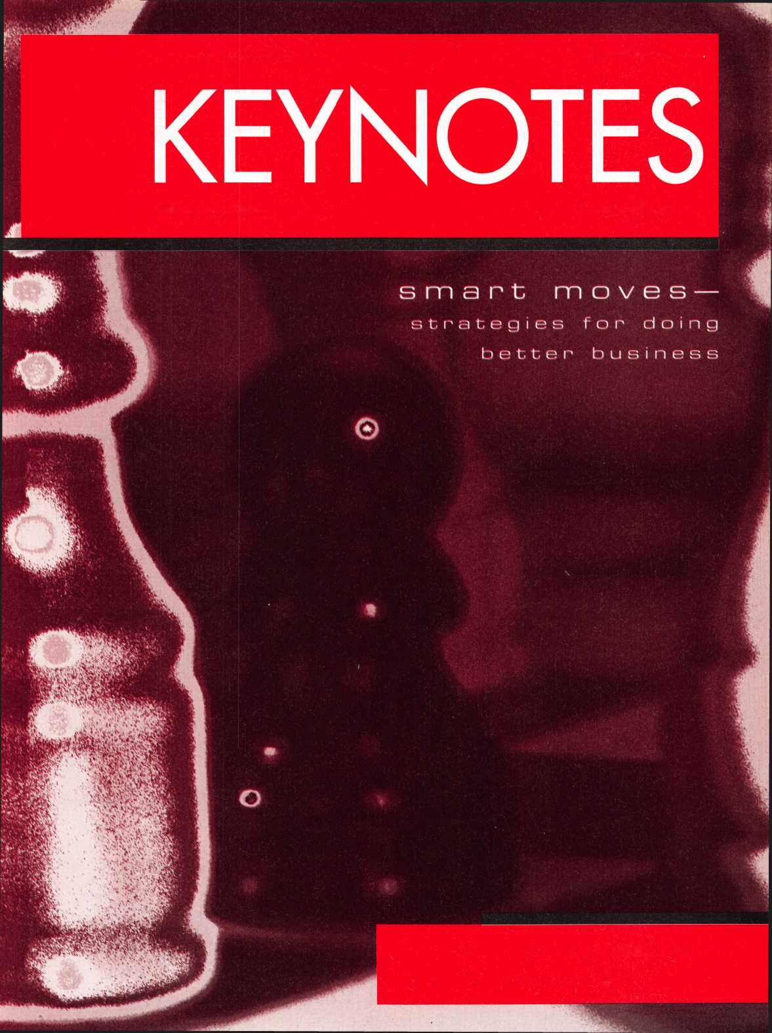

“If you want to study for the CPS test,

you need **this** book.

Without that book, I wouldn’t have my certification.”

-Dennis Johnson, CPS  
Aurora, Illinois

"Mike's new book is very  
consistent with the study  
information required to pass the  
SAVTA/ALOA CPS certification  
test. I wouldn't have passed  
without it. *A tremendous  
resource for today  
and tomorrow..."*

-John T. Grist; CML, CPS  
North Georgia Security

"The Safe Technicians Reference Manual by Mike Oehlert ranks among the best technical reference and learning aids you will find in the safe and vault industry. It contains page after page of essential information and easily understood illustrations. Besides answering most of the questions commonly asked by technicians new to the field, Mike has also included plenty of information experienced technicians will find useful."

-Ken Dunckel Pacifica, California

—►Over 600 Illustrations.-*—

320 pages. Only $135,

What are you waiting for?

To order, call 800-532-2562. Allow 3 weeks for delivery.

All major credit cards accepted; or make check payable to ALOA.

The Safe

Technicians  
Reference Manual

First Edition

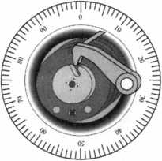

contents

**staff**

KEYNOTES **STAFF**

|  |  |
| --- | --- |
| Editor | Mike Emery keynotes@a net-dfw. com |
| Technical Editor | David Lowell, CML, CMS [david@aloa.ioffice.com](mailto:david@aloa.ioffice.com) |
| Communications/ | |
| Financial Coordinator | Patanya Johnson |
| Editorial Advisor | John D. Cannon, CML [jdcannon@worldnet.att.net](mailto:jdcannon@worldnet.att.net) |
| Advertising | Marvin Diamond  Native American Journal Co. (706) 782-0878 [thediamonds@mindspring.com](mailto:thediamonds@mindspring.com) |
| Contributing Editors | Paul Chandler, CRL  Claire Cohen, CML  Sal Dulcamaro, CML |
| Contributing Authors | Jerome V. Andrews, CML Brian Costley, CML, CMS  Bob De Weese, CPL  Ray D'Adamo, CML  Michael A. Ferrill  James Glazier, CML  Daniel Graffeo, CRL, CMS Wayne Gurnee, CRL  A.J. Hoffman, CML  Ken Holmlund, CRL  Ray Lusk, CML  Mark Ohno  Randy Simpson, CML  Robert Stafford, CPL  Dave Thielen, CML |
| ALOA PROFESSIONAL STAFF | |
| Executive Director | Charles W. Gibson, Jr., CAE [charlie@aloa.ioffice.com](mailto:charlie@aloa.ioffice.com) |
| Operations Manager | Mary May  [mary@aloa.ioffice.com](mailto:mary@aloa.ioffice.com) |
| Comptroller | Kathy J. Romo |
| Meetings Manager | Jessica Smith [jessica@aloa.ioffice.com](mailto:jessica@aloa.ioffice.com) |
| Government | |
| Affairs Manager | Tim McMullen ti m@aloa. ioffice. com |
| PRP/Education Manager | David Lowell, CML, CMS [david@aloa.ioffice.com](mailto:david@aloa.ioffice.com) |
| PRP/Education Coordinator Ashley Spencer | |
| Membership Coordinator | Shelly Jett |
| Chapters & Regional | |
| Associations Liaison | Tim McMullen [tim@aloa.ioffice.com](mailto:tim@aloa.ioffice.com) |
| Information Systems | |
| Manager | Randy McChristian |
| Receptionist | Barbara Ortiz |

ALOA EXECUTIVE BOARD

|  |  |
| --- | --- |
| President  Secretary | John J. Greenan, CML, CPS (773) 486-2030  John D. Cannon, CML (703) 960-6413  Mark E. Blum, CML, CPS (517) 482-5809  Tom Ripp, CRL   1. 262-3831   James H. Glazier, CML (301)831-5454  John C. Magee, III   1. 845-3434   William L. Young, CML   1. ) 647-5042 |
| Directors, North Central |
|  |
|  |
| Directors, Northeast |
|  |
|  |
|  |
|  |
| Director, Northwest | Scott L. Henke, CRL, CPS (907) 248-3785 |
| Director, South Central | Randy L. Simpson, CML (713)780-7026 |
| Directors, Southeast | Thomas W. Tate |
| (850) 476-4211  Donald E. Rule, CML (601) 324-2658  Gordon R. Racine, CML (719) 384-4707  John A. Ilk, CRL |
|  |
|  |
| Directors, Southwest |
|  |
|  | (602) 420-2174 |
| Director, Associate Members | |
| Judd Penske (800) 634-5465 |  |
| Trustees | Dallas Brooks (334) 826-8990 |
|  | David M. Lowell, CML, CMS (800) 532-2562  Breck H. Camp, CML (770) 455-6244  Edwin Toepfer, RL (416) 225-5589 |
| ALOA PAST PRESIDENTS | |
| 1997-1999 | Dallas C. Brooks |
| 1995-1997 | David Lowell, CML, CMS |
| 1993-1995 | Breck Camp, CML |
| 1991-1993 | Henry Printz, CML |
| 1989-1991 | Evelyn Wersonick, CML, CPS |
| 1987-1989 | Leonard Passarello, CPL |
| 1985-1987 | Joe Jackman, CML |
| 1983-1985 | Stanley Haney, CPL |
| 1981-1983 | Louis LaGreco, CPL |
| 1979-1981 | John Kerr, RL |
| 1977-1979 | Clifford Cox, CML |
| 1974-1977 | Charles Hetherington |
| 1972-1974 | Gene Laughridge |
| 1970-1972 | William Dutcher, RL |
| 1968-1970 | Constant Maffrey, RL |
| 1966-1968 | Harold Edelstein, RL |
| 1964-1966 | William Meacham |
| 1962-1964 | Robert Rackliffe, CPL |
| 1960-1962 | Edwin Toepfer, RL |
| 1956-1960 | Ernest Johannesen |

Mission Statement: The Associated Locksmiths of America, Inc. is dedicated to enhancing the professionalism, education and ethics among locksmiths and those in related sectors of the physical security industry. With approximately 10,000 members in the United States, Canada and the free world, ALOA is poised to help members obtain the knowledge, the strength, and the confidence to perform their role in the physical security field with pride and dignity. But it is only through active involvement and participation that ALOA can fully achieve its potential—and can help members to achieve theirs.

Policies: Keynotes® is the official publication of the Associated Locksmiths of America, Inc. (ALOA). Keynotes<s> acts as a moderator without approving, disapproving, or guaranteeing the validity or accuracy of any data, claim, or opinion appearing under a byline or obtained or quoted from an acknowledged source. The opinions expressed by the authors do not necessarily reflect the official views of ALOA. Also, appearance of advertisements and new products or service information does not constitute an endorsement of products or services featured by the Association. The Association does not accept responsibility for the inaccuracy of any data, claim, or opinion appearing in this publication, due to typographical errors on the part of the authors, Association staff or its agents.

Editor's Note: This publication is designed to provide accurate and authoritative information in regard to the subject matter covered. It is provided and disseminated with the understanding that the publisher is not engaged in rendering legal or other professional services. If legal advice and other expert assistance is required, the services of a competent professional should be sought.

Authors7 Payment: Payment for eligible submissions to Keynotes will be based on the following criteria: topic, time spent and past contri­butions. Authors who regularly submit to Keynotes are generally paid a higher rate. The latter is especially true of authors who write to fit specific editorial needs and submit said copy by Keynotes deadlines. As a general guideline: Average payment for a 750 word, business or light' technical article would be $200. Payment for a 1500 word article involving significantly higher time and research efforts would be $400.

Payment will not be offered for articles submitted by ALOA employees or members of the ALOA Board of Directors (unless material is of a technical nature), nor for articles submitted by a company that promote that company's products or services. ALOA reserves the right not to pay for articles submitted by an individual(s) that promote a particular company's products or services.

Disclaimer: The Associated Locksmiths of America, Inc., (ALOA), reserves the right to refuse any article for any reason. Additionally, ALOA reserves the right to edit, amend or modify any article submitted for publication in order to preserve technical accuracy, clarity, fairness or grammatical correctness. ALOA will make the best efforts to notify the author of any changes. The extent of ALOA's liability for any article or information contained therein will be a notice of correction or retraction in the next possible issue.

Keynotes9 (ISSN 0277 0792) is published monthly except for the combined June/July issue by The Associated Locksmiths of America, Inc., 3003 Live Oak St., Dallas, TX 75204-6186. Telephone: (214) 827-1701; FAX (214) 827-1810; e-mail [aloa@aloa.org](mailto:aloa@aloa.org). Subscription rates for members— $15.00 per year. Second class postage paid at Dallas, Texas. POSTMASTER: Send address changes to: Keynotes 3003 Live Oak St., Dallas, TX 75204-6186. © Copyright 2000, All rights reserved. No part of the contents may be reproduced or reprinted in any form without prior written permission of the publisher.

President's Journey

By John i. Greenan, CML, CPS

Hiring 101:

How To Hire A New Employee

By Claire Cohen, CML

So, you want to be a small town locksmith? Part II

By C.D. Lipscomb, CML, CPS

Locksmithing in the Information Age

By Paul Chandler, CRL

The Credit Battle

By Don Dennis, CPL

6 Upcoming Events 9 Product Showcase

Hit Associate Members

26 Classifieds

Additional contact information for the ALOA Board and most Keynotes authors is available through "locksmith Search" on the ALOA website - [www.aloa.org](http://www.aloa.org), or by contacting the ALOA office at 3003 Live Oak Street; Dallas, TX 75204; (800)532-2562; FAX (214)827-1810; e-mail [aloa@aloa.org](mailto:aloa@aloa.org).

**DEPARTMENTS**

1

KEYNOTES FEBRUARY 2000



Board Nominations

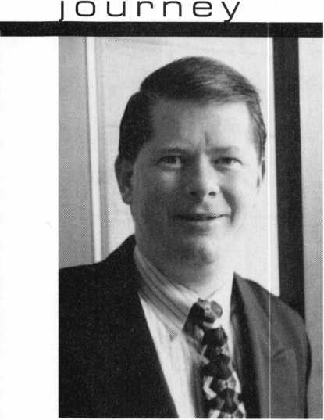

president’s

It's that time again. Time to start thinking about voting on ALOA Board Members. Most importantly, it's also time to think about WHO should run and WHY.

There are plenty of reasons to consider becoming an ALOA Board member. For starters, this is a golden opportunity to represent your region of the United States and address the needs and concerns of security professionals in your area. Such a leadership role not only bolsters one's credibility as a locksmith but aids fellow professionals in a variety of matters such as educational and legislative issues.

Another reason to consider becoming a Director on ALOA's Board is the fact that this is a chance to effectively shape the direction of this organization. As we are entering an entirely new age of security technology, ALOA is evolving faster than ever. Its Board needs perspectives from a variety of personalities. With that, everyone's insight is valuable.

This year, there will be seven positions open for election. They include Secretary and directors from the following regions:

Northeast three directors

Northwest one director

South Central one director Associate Region one director

The deadline for Board nominations will be here before you know it. All nomination forms and petitions should be received by March 31 and sent to:

Nominee Profile

Secretary of the Board of Directors Associated Locksmiths of America 3003 Live Oak St.

Dallas, TX 75204-8186

I encourage each and every one of you to read over the nomination form and petition on pages 14 and 15 of this very magazine. Participation is instrumental to the growth of this organization as well as its future direction.

John J. Greenan, CML, CPS

KEYNOTES

FEBRUARY 2000

2

you have already noticed, this issue of Keynotes is radically different from last month's. Please note that this is merely a temporary change as we are trying to research new ways to present ALOA members with quality articles and helpful information.

As ALOA enters an entirely new age, Keynotes is striving to meet the needs of the membership. With that, we are looking beyond our current format in an attempt to discover what will benefit our readers and the Association.

The most important thing to remember is, this is YOUR magazine. Therefore, your feedback and support are vital.

It's safe to say that some of you may prefer this issue to our regular format. Likewise, many of you may like the way Keynotes has looked for the past few years. Whatever the case, let us know.

Your responses are instrumental to the future of Keynotes. They will also have an influence on our next "test" issue scheduled for October 2000. As mentioned earlier, well return to our regular format next month.

Until then, I hope you enjoy this month's "Business" issue, with articles concerning various administrative topics and practices.

Mike Emery

a I oa

On Law Enforcement Officer Duties  
Regarding Requests to Open Locked Motor Vehicles



General Rule

ALOA believes that officers of police departments or fire departments (herein referred to as the agency) should not open locked vehicles unless an emergency situation exists. In non-emergency situations, the officer on the scene or the dispatcher should refer motorists to qualified locksmiths in accordance with the procedures contained within the policy.

Referral Procedures

The officer on the scene or the dispatcher should use one of the following methods for referrals to locksmiths:

* PRINTED LIST

Officers should be provided with a list of local area locksmiths, including hours of operation, which may be used to give a motorist information to allow them to contact a locksmith directly.

* RADIO DISPATCH

The officer on the scene should use the two-way radio to contact the dispatcher. The dispatcher, when contacted by the officer or if telephoned directly by the motorist, should contact the next available locksmith and request that the locksmith go to the scene and assist the motorist.

Definitions

* AGENCY

A law enforcement department, fire department, or other public service agency.

* EMERGENCY SITUATION

Any life threatening or personal injury situation is to be considered an emergency. Other situations, even those where the motor vehicle's engine is running, or where the motor vehicle is blocking passage, are not considered emergency situations unless there are extenuating circumstances apparent to the dispatcher or the officer on the scene which, in his or her judgement, would classify the situation as an emergency. Vehicle entry in an emergency situation should be accomplished by the fastest possible method including forced entry or glass breakage.

* LOCKSMITH LIST

A list of all local area locksmiths who agree to respond to official requests and who agree to the terms and conditions of this policy.

* NEXT AVAILABLE LOCKSMITH

Referrals made from a locksmith list should be done on a rotational basis so that each locksmith has approximately an equal number of referrals, and the locksmith who is next in line for a referral is to be considered the next available locksmith.

Terms and Conditions for Participating Locksmiths

As a condition to be listed on the locksmith list, ALOA believes that a locksmith must agree to the following terms and conditions. Violations of any of the following terms and conditions should be grounds for removal from the locksmith list for a period of one year.

* PROOF OF PROFICIENCY

The locksmith shall provide adequate proof that he or she is regularly engaged in the locksmith business. Adequate proof shall be, but is

not limited to, copies of business licenses, proof of completion of locksmith courses, membership in ALOA or any recognized local association, or proof of achievement of one of the PRP designations of ALOA. A locksmith company shall present such proof on behalf of its employees.

* COMPLIANCE WITH STATE LAWS

The Locksmith should comply with all state laws regarding the regulation of locksmiths, if any, including requirements for bonding, licensing and equipment standards. A locksmith company shall be responsible for its employees.

* PROMPT RESPONSE

The locksmith should agree to respond to official agency requests to open locked motor vehicles as soon as possible, and on a priority basis.

* NO PREMIUM RATES

The Locksmith should agree to charge the same rates to people referred by the agency as would be charged to customers under similar circumstances but not referred by the agency.

* HOLD HARMLESS

The locksmith should agree to hold harmless the agency and its personnel against any liability which was caused as a result of a locksmith referral or as a result of any missed calls.

* PROVIDE INFORMATION

The locksmith should provide the agency with up-to-date information regarding the company name, address, phone numbers, hours of operation and geographical area covered.

* PAYMENT

The locksmith may request the payments be made immediately in cash, but should accept checks or credit cards in lieu of cash if there is no reasonable alternative.

Creation and Maintenance of Locksmith List

The following steps should be used to create and maintain the locksmith list:

* PREPARE APPLICATION FORM

The agency should prepare and make available to all interested persons an application for locksmiths to request that their name or company name be placed on the locksmith list.

* PREPARE LOCKSMITH LIST

The agency should prepare a locksmith list for each geographical area it serves, and provide all officers and dispatchers with copies of the list.

* DISCLAIMERS

If the list is to be distributed as a handout to motorists, the list should contain a disclaimer on the part of the agency as to the quality, promptness and any liability regarding the locksmiths services.

* MAINTAIN LIST

The agency should update the locksmith list as needed.

Disposal of Agency Owned Lock Opening Tools

All agency owned lock opening tools (slim jims and others) should be recovered from all officers and stored in the agency headquarters.

KEYNOTES FEBRUARY 2000

4

aloa reinstatement policy

There are two methods available for a member to be reinstated after a lapse in their membership, and allow the retention of their original member number:

1. Full payment of all past and current dues will allow their "member since" year status to continue to be shown as

the year in which they initially joined the association and they will be afforded all benefits that are currently available.

1. Full payment of an Administrative Fee, (currently $40.00) as well as all current dues will change their "member since" to the year

in which they were reinstated.



MLANJ 2000 Annual Convention

April 6th thru April 9th Somerset, New Jersey

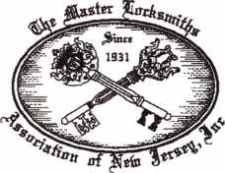

**Fop** More Information:

PO Box 2441, Morristown, NJ 07962-2441 Phone 973-267-8884 Fax 973-538-2248

Or visit our web site at [www.MLANJ.org](http://www.MLANJ.org)



SECURITy

LOCK COMPANY

**New** Factory Replacement Parts and Locks for Security Corporation and Kumahira Safe Co. Products

* Safe Deposit Box Locks and Parts BX, KD
* Automatic Remote Tube Systems (ARTS)
* Drive Up Systems
* Vault Doors
* Night Depositories
* Camera Systems
* Key Blanks and
* Keys Cut to Code

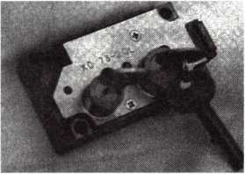

KD Series

Safe Deposit Box Locks

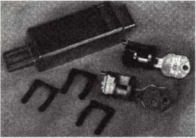

BX Series Safe Deposit Locks

1155 Chess Drive, #114 Foster City, CA 94404 Phone: (650)525-0660 Fax: (650) 525-0444

Email:

[chaslutz@securitylockco.com](mailto:chaslutz@securitylockco.com)

secuRiTy **m**

LOCK COMPANY

5

KEYNOTES FEBRUARY 2000

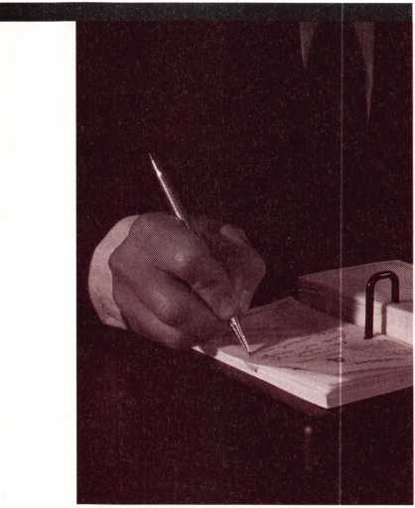

upcoming

events

**2000**

FEBRUARY

5-6

23rd Annual Antique Lock Show Arcadia, CA

Sponsor: West Coast Lock Collectors Contact: Bob Heilemann

(310) 454-7295 voice mail (310) 230-3004 evenings only Doug Huse (626) 797-1610

9-10

Biaxial Certification KeyMark Certification Houston, TX

Sponsor: Medeco Contact: Lisa Burton

(540) 380-1826

8-13

TLA Annual Convention and Trade Show **^** PRP Sitting Houston, TX

Sponsor: The Texas Locksmiths Association Contact-Registration info:

Jim Hetciller (830) 606-1727 Contact-Exhibitor info:

Robert Hernandez (210) 433-5397 Contact-General info:

(877) TLA-INFO

10-12

ALOA Board Meeting Las Vegas, NV

Call: (800) 532-2562

23-26

Svc Coordinator Training SiteLine Certification Biaxial Certification KeyMark Certification Kansas City, MO Sponsor: Medeco Contact: Lisa Burton

(540) 380-1826

26-27

Investigative Locksmithing I & II Sacramento, CA

International Association of Investigative Locksmiths Inc Contact: Dan Kern (916) 508-4026

MARCH

10

**^** ALOA PRP Sitting Dallas, TX

Contact: David Lowell, CML, CPS

(214) 827-1701 (214) 827-1810 fax

11-12

OPLA Annual Retreat Eureka Springs, AR

Ozark Professional Locksmith Association Contact: Betty Gray

(501)524-3660 Bill or Janis Reves (501)631-0017

12

**^** ALOA PRP Sitting Rosemont, IL

Sponsor: Clark Security Products Contact: Ron Cooling

(858) 974-5273 (858) 974-5284 fax

13-16

SiteLine Certification Biaxial Certification KeyMark Certification Salem, VA

Sponsor: Medeco Contact: Lisa Burton

(540) 380-1826

14-16

ISC West Las Vegas, NV

(800) 840-5602 or (203) 840-5802 isc.reedexpo.com

1. 19

Trade Show & Security Conference Troy, Ml

Sponsor: IDN Hardware Sales, Inc. Contact: Fred Strasberger or

Bonnie Weston (800) 521-0955

18

Georgia Chapter Monthly Meeting Atlanta, GA

Georgia Chapter of ALOA IDN Armstong 9 am Contact: Steve Gebbia

(770) 455-6242

1. 19

Buyers Trade Show & Classes St. Petersburg, FL

Sponsor: Southern Lock & Supply Co. Contact: (800)282-2837

[www.southernlock.com](http://www.southernlock.com)

26

**^** ALOA PRP Sitting Hattiesburg, MS

Sponsor: Lou-Miss Locksmith Association Contact: John Kiick, CML (601)649-5426 (601)649- 5426 fax

APRIL

2

ALOA PRP Sitting Oakland, CA

Sponsor: Clark Security Products Contact: Ron Cooling

(858) 974-5273 (858) 974-5284 fax

6-9

MLANJ Annual Convention ^ Ace Classes

Master Locksmith Association of New Jersey Somerset, NJ

(800) 675-6997 [www.mlanj.org](http://www.mlanj.org)

KEYNOTES FEBRUARY 2000

6

14

ALOA PRP Sitting Dallas, TX

Contact: David Lowell

(214) 827-1701 (214) 827-1810 fax

18

Georgia Chapter Monthly Meeting Atlanta, GA

Georgia Chapter of ALOA IDN Armstong 9 am Contact: Steve Gebbia (770) 455-6242

1. 24

Master Locksmith Association Easter Convention 2000 Birmingham, England Master Locksmiths Assoc, in the UK

Contact: Mick Friend

[Mick@locksmiths.co.uk](mailto:Mick@locksmiths.co.uk)

Registration forms are available through ALOA by calling 1.800.532.2562

26-29

Security Hardware Distributors Association (SHDA) Conference Jacksonville, FL

(215) 564-3484 [www.shda.org](http://www.shda.org)

**MAY**

1-6

SAFETECH 2000 **^** PRP Sitting Birmingham, AL

(214) 827-7233

9-10

ISC Expo Miami, FL

(800) 840-5602 isc.reedexpo.com

12

**^** ALOA PRP Sitting Dallas, TX

Contact: David Lowell

(214) 827-1701 (214) 827-1810 fax

17-20

ELF Convention Sofia, Bulgaria

[www.bcci.bg/-clients/alob](http://www.bcci.bg/-clients/alob)

JUNE

21-22

ISC Chicago Chicago, IL

(800) 840-5602 (204)840-5802 isc.reedexpo.com

JULY

24-30

ALOA 2000 Security Expo ^ Ace Classes **^** PRP Sitting Las Vegas, NV

(214) 827-1701

AUGUST

28-31

ISC East New York, NY

(800) 840-5602 isc.reedexpo.com

SEPTEMBER

7-9

DHI Convention San Francisco, CA

Contact: Kathy Devey

(703) 222-2010

8-10

TAOL 27th Annual Convention Toronto, ON Canada

Contact: Don DeKuyper

(416) 321-2219 (888) 272-8265

11-14

ASIS Show Orlando, FL

(703) 522-5800 [www.asisonline.org](http://www.asisonline.org)

20-24

GPLA **50+1** Convention Philadelphia, PA

Contact: Nelson Dayton

(610) 688-9188

[www.gpla.org](http://www.gpla.org)

7

OCTOBER

13-15

SERLAC

Jacksonville, FL

Contact: James Riley

(941)294-8679

23-27

Tri-Regional Show Seattle, WA

Contact: Kathy

(847) 692-5940

NOVEMBER

6-10

Yankee Security Conference Sturbridge, MA

(800) 209-8266

2001

MARCH

MARCH 28-APRIL 1

MLANJ 2001 Annual Convention Somerset, NJ

(973) 267-8884 (973) 538-2248 fax [www.mlanj.org](http://www.mlanj.org)

JULY

16-22

ALOA 2001 Security Expo Baltimore, MD

(800) 532-2562

**2002**

JULY

22-28

ALOA 2002 Security Expo Rosemont, IL

(800) 532-2562

KEYNOTES FEBRUARY 2000

To boldly  
go where your

business or career  
has never gone  
before, you need the

latest training, product  
information, and tools.

The entire universe  
of locksmithing can be  
explored at one great  
show—ALOA 2000 in Las  
Vegas, Nevada. You can  
also beam aboard the  
Las Vegas Hilton's newest

attraction — Star Trek:  
The Experience.  
For more information  
visit our website at  
<http://www.aloa.org/>  
and set your course

for ALOA 2000.



product

showcase

**ADESCO SAFE**

**Manufacturing Co.**

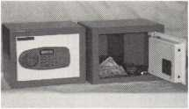

Model GS-5E

The new Adesco "Guest Safe" is designed for hotels, dorm rooms, or any application where temporary storage is a necessity. The GS's electronic lock operates with a standard hotel room configuration. Additional features include manager override code, master override key, predrilled bolt holes, hanckfelted false bottom, and guest card instructions.

Adesco Safe  
Manufacturing Co.

16720 Garfield Ave.  
Paramount, CA 90723  
(800) 821-8803  
562) 630-1503  
Fax (562) 408-6427  
[www.adesco.com](http://www.adesco.com)

**A&B SAFE  
Corporation**

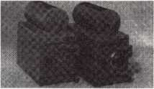

A&B Safe Corporation is a leading manufacturer of quality depository safes and chests. Our product line is the most extensive in the industry with over 75 models in stock. Our safes are "B" rate construction (1/4" body and 1/2" door solid steel) and are equipped with our patented dove­tail boltwork. Our product line also includes TL rated safes, fire safes and insulated files, safe deposit boxes, hotel safes, and vaults. We also build custom safes to your specifications.

A&B Safe Corp.

171 S. Delsea Drive  
Glassboro, NJ 08028  
(856) 863-1186  
Fax (856) 863-1208  
[www.A-Bsafecorp.com](http://www.A-Bsafecorp.com)

**ALOA**

**2000**



There is no better place in the universe for locksmiths to receive concentrated, comprehensive, top- level continuing training than at ALOA's annual convention.

Industry masters and business gurus from around the world instruct students in trade

techniques, business applications, and more

Las Vegas, NV  
July 24-30, 2000

Associated Locksmiths  
of America

3003 Live Oak Street  
Dallas, TX 75204  
800.532.ALOA  
214.827.1701  
Fax 214.827.1810  
[www.aloa.org](http://www.aloa.org)

**STRATTEC's**

**D.A.R.T.**

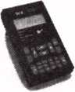

Chrysler vehicles equipped with the SEntry Key Immobilizer System require both the correct mechanically cut key and transponder to start the vehicle. STRATTEC's Diagnostic and Programming Tool (D.A.R.T.) lets you program the vehicle to accept new key codes (up to eight per vehicle). Pre-programmed codes can also be deleted if keys are lost or stolen. Build for years of rugged use, the D.A.R.T. is simple to use, with an easy-to-read LCD display and multiple-function keypad to move quickly through operational menus. This new system includes everything you need to handle the Chrysler S.K.I.M.-kit's your key to the next generation of vehicle security.

Strattec Security Corp.

333 West Good Hope Road  
Milwaukee, Wl 53209  
(414) 247-3415  
Fax (414) 247-3329

the Servi*ce Kit*s! Just give me

Kf

Match the lock to the customer's key  
without having to purchase a service kit.  
Uncoded lock, tumblers, springs,  
caps, are included. Everything you need

(except the key) in one easy kit.

-Fast!

-Easy!

-Cost Effective

Available through BWD Automotive Distributors!

For a listing of available Premium Pack locks and BWD's parts catalog, contact BWD at (800) 647-4926.

im

9

KEYNOTES FEBRUARY 2000

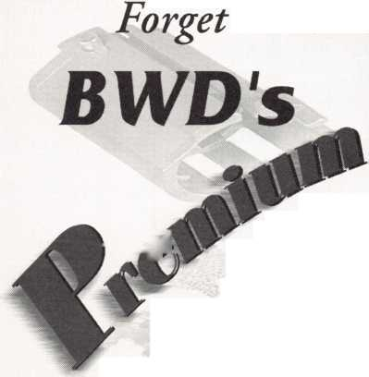

The following applicants are scheduled for clearance as members of ALOA. The names are published for member review and comment prior to March 1,2000, respectively, to ensure applicants meet standards of ALOA's Code of Ethics. Protests, if any, should be addressed to the Membership Department and must be signed. Active Membership applicants (A) have worked in the industry two or more years. Allied Membership (AL) applicants are not locksmiths, but work in a security-related field. Apprentice Membership (AP) applicants have worked in the industry

It's True

Marray has developed the first  
screwless door loop.

Aluminum ma­terial means true anodizing.

No off color powder coat­ing or painting

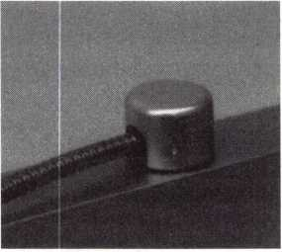

Standard 18”  
length. Can be  
ordered in cus-  
tom lengths

Plastic base stops  
shorts and pro-  
tects wires

Screwless base and cap means you drill two 1/2 inch diameter holes, pop the base into the hole, wire your system and snap on your covers. Simple as 1,2, 3.

**Here’s the best part We are giving away a**

FREE SAMPLE TO THE FIRST **lOO** CALLERS WHO MEN­TION THIS ADD. **A $14.40** WHOLESALE PRICE VALUE.

CALL TODAY, IT’S FREE!!

1-800-500-1449

Marray *enterprises, inc.*

At Marray, we’re not just modifiers, we’re Master Hardware Modifiers™  
1128 Walsh Ave., Santa Clara, CA 95050. [www.marray.com](http://www.marray.com)

**USA**

CALIFORNIA

Imperial Beach

James L Hood

COLORADO

Colorado Springs

Matthew F Crawford

CONNECTICUT

Waterbury

Robert A Gabris Jr

WASHINGTON, DC

Paul E Tangren

FLORIDA

Naples

Jay C Andringa

HAWAII

Honolulu

Louis J Souza Sr

ILLINOIS

Darien

Donald Johnson

Litchfield

Rick C Bridgess

MICHIGAN

Lansing

Dale W Verran

NEW JERSEY

Totowa

Ed Voorhis

NEW YORK

Jackson Heights

Benjamin Plaza

TEXAS

Forney

Richard A O'Connor

VIRGINIA

Alexandria

Joshua J Laboskie

WISCONSIN

Slinger

Michael A Egan

**CANADA**

BC

Vancouver

Peter Anderson

KEYNOTES FEBRUARY 2000

10



HIRING 101

HOW TO HIRE A NEW EMPLOYEE

BY CLAIRE L. COHEN, CML

^Jne of the most important decisions every locksmith/security business faces is deciding to hire a rew employee. Regardless of whether you own a large locksmith/security business, or a small mobile shop or whether this is your first employee or your 100th employee the decision to bring a new locksmith, locksmith trainee, counter staff person, or administrative person into your business is something that should not be taken lightly. You are faced with trying to find a good employee, and someone who is technically qualified (or has the aptitude and is willing to learn the trade), and will fit into your business style. There are legal ramifications associated with the hiring process. Here are some tips to help you find the right person for your company.

If your company has established procedures addressing the hiring process, you must ensure that these procedures are followed. An example of the type of issues that you might encounter is a requirement that any job opening be advertised internally before being advertised externally.

Take the time to create a written job description for the position that you are trying to fill. This exercise will firm up in your mind exactly what duties this new employee will perform. The written job description is something that you can supply to the potential employee during the interview. This will serve to trigger discussion points during the interview. This will not only help you find the right person for the job, but it will also serve as documen­tation for your new employee when he/she starts the job.

Decide upon the benefits package that will be offered to the employee ahead of time. Once again, it is important to check whether there are any procedures set forth by your company regarding benefits. Unless your company's policy is set in stone, you may decide to offer a prospective employee a better benefits package than that offered to other existing employees.

An extra week's vacation is a small price to pay to attract the right person. Beware, however,

that making exceptions to your general policies may raise resentment from the rest of your staff.

In order to find the right employee, you may wish to advertise the position in newspapers. This can be very expensive. Make sure your ad is succinct, yet contains all of the relevant information. For example, ensure that you have listed the job title, mention minimum qualifi­cations needed to be considered for the job, and how to apply. If overtime, travel, etc. are required for the position, it may be wise to put that in the ad also. Publish the procedure for applying: telephone number, address, fax number or e-mail addresses. Consider other options such as listing your job opening at the local college. Perhaps you could place an ad in a local association newsletters or Keynotes Magazine. Another alternative would be to ask the local associations/ALOA Chapters to make verbal announcements at meetings.

When resumes, application letters, phone inquiries are received, ensure that your job description and benefits package is close at hand. This will help you weed through applicants and eliminate those that are overqualified, under-qualified or otherwise not appropriate.

It is a good idea to have the prospective candidate complete a job application form prior to the interview. If your company does not have a standard form job application, they can be purchased through office supply sources. The job application will give you the opportunity to find out more information, other than what was contained on the resume, letter of introduction or telephone call. This application will let you find out more about the applicant's education, prior work experience and technical skills needed for the job.

The interview is the opportunity for you to personally meet the applicant. It is the time for you to introduce the scope of the job, your company and your philosophy in an effort to determine whether this person is right for the job. It is also the opportunity for the application to evaluate you and your company.

With that in mind, make sure you provide an adequate amount of uninterrupted time for each interview. Review the resume/employment application in advance, and know the answers to basic questions that will probably to asked, such as salary, work schedule, etc.

Avoid asking any personal questions. What may appear to be innocent questions such as "Are you married?" or "That is an interesting accent, where are you from?" could subject you to employment discrimination.

Ask that prospective candidates furnish you with a list of references (with current address and phone numbers). Take the time to check these references. To avoid liability, many companies have a set a policy of only verifying employment dates, position and salary. Don't be surprised if these are the only pieces of information that are made available to you.

Once you have made the decision to hire someone, it is advisable that you put the offer in writing. The offer should include the job title, the starting salary and all benefits terms. This will ensure that there is no confusion as to what is being offered to the prospective employee.

Once you have made the decision not to hire someone, consider sending a rejection letter. Keep the letter short and avoid stating any particular reason why the applicant was not chosen for the job. Not only is it common courtesy to send a letter to all who interviewed for your job opening, but it shows appreciation for their time and effort they have expended during the hiring process. Keep a file with job applicant resumes / applications. This may be valuable when you have another job opening. Remember that today's rejected applicant may be next year's new employee.

The hiring process is a critical part of running a successful locksmith/security business. The wrong candidate cost your business time and money. The right candidate may be the next great thing to happen to your business. Take the time to do it right and you won't be sorry.

11

KEYNOTES FEBRUARY 2000

SO, YOU WANT TO BE A SMALL TOWN LOCKSMITH?

Part 2: The Good Part

BY C. D. LIPSCOMB, CML, CPS

^\bout a year ago, I wrote about what it takes to be a small town locksmith. One reader told me I was accurate in much of what I said, but I should have covered more of the good points as opposed to the drawbacks.

Of course, there will always be the trials and tribulations that I documented in my March '99 article. Being a small town locksmith, however, is probably as rewarding as anything I have ever done in my life. Am I (or is any small town locksmith, for that matter) likely to get rich? It could happen, but it is far more likely that one will just make a living that is comfortable most of the time, and not so good at other times. If money were the driving force, most of us would look for a place where there is a lot of money being spent, like a large city.

Most of us who become locksmiths do so in the area where we were raised or have settled later in life. We don't necessarily look for a profitable city to locate in, we tend to set up where we are. For some of us, that happens to be a small town. While there are a lot of reasons not to try locksmithing in a small town, there is so much to be said for living and working there. I will try to list a few things that come to mind.

You have a sense of "home". You become very protective and proprietary about your customers and your town. In a small community, you have the advantage of knowing and being known by everybody there. You become an important part of the community and that is a good feeling. It gives you an additional sense of purpose about your life to know that you are needed and that your neighbors look to you for their security.

You don't have a lot of the ills that befall a big city. There is not as much crime or people with "attitude". You actually tend to get complacent about your own security. I have forgotten to lock my shop doors a time or two in the last ten years and nothing bad happened. Sometimes, that can work against you. I have

joked that High Security in my town, is TWO screen door hooks. Sometimes, it is hard to sell really good hardware to someone who has never had a problem. It is nice, however, not to worry about muggings and gang violence. If it weren't for the violence on television and the nightly news from the city, we couldn't sell a lock at all. A lot of people don't lock their doors here anyway.

You get to charge mileage. Most of your jobs are "out of town". It is much easier for a customer to accept a mileage charge for driving out into the country than in the city. Most big city locksmiths have a hard time charging mileage within the city limits, and their city limits may be 50 miles or more across. Consequently, even though we may charge less for a trip charge, the final bill is often higher. It doesn't take us as long to go further and we don't have to deal with stop-and-go driving.

You don't usually have traffic jams. You can actually tell someone who is 15 miles away, that you will be there in 20 minutes, and usually make it there on time. A train across the road is the usual major problem that you have to deal with in getting anywhere. The stress level while driving in rural America is almost non-existent in comparison to big city driving. Of course, you have to watch out for farm animals on the road sometimes.

Your insurance rates are much less on almost all policies except medical. There are fewer wrecks, lawyers, insurance agents, fires and break-ins in a small area, thus less claims.

There is no smog problem. The only air pollution is when a cattle truck goes by. Then, whoo!! No to mention "Red Beans and Cabbage" day at the local cafe.

You actually get to be friends with most of your customers. In fact, you get to work for old friends on a daily basis. It just seems easier to make friends in a small town. There is not the anonymity that there is in a big city where people want your services, but not to know you.

Your friends and acquaintances may try to use you, but people find it harder to cheat you or steal from you in a small town where you will see them tomorrow. You take really good care of your friends, they take care of you, and an enemy can be easier to spot.

It is easier to gain recognition in a small town. You have an added incentive to do good work, and be the best that you can be. This rewards a good locksmith. A person striving for excellence is in his element here. For good or bad, the word gets around quickly. There is an old saying that says "If you are going to cut keys in a small town, you better cut good keys." It is an old saying simply because I started saying it a long time ago. However, it is sooo true. Just as your mistakes will quickly haunt you in a small town, your successes can as quickly gain the notice of the entire community.

Your yellow page advertising is cheaper. Actually it is the same rate, as these things are based on the number of people reached by their book. This is both good and bad. The bad part is that there aren't many people around, so you have to go further out to make a living. The good part is, you get to go further out to make a living.

You gain a position of respect in the community. While a person working in the security field in a large city may be referred to as "a locksmith," the same person working in a small town will become "The Locksmith". Does that small distinction really matter? It does to me, and I suspect many of the other small town locksmiths throughout the country feel the same.

Doggone it, I have made it sound so good, that I may just stay here!

Seriously, I would not trade what I am doing, and where I am doing it for all the tea in china. I am at home, This is what I do, these are my people, and I love every minute of it. As hard as it can be to work in a small town, for me it is worth it. I think it is the same for most small town locksmiths.

KEYNOTES FEBRUARY 2000

12

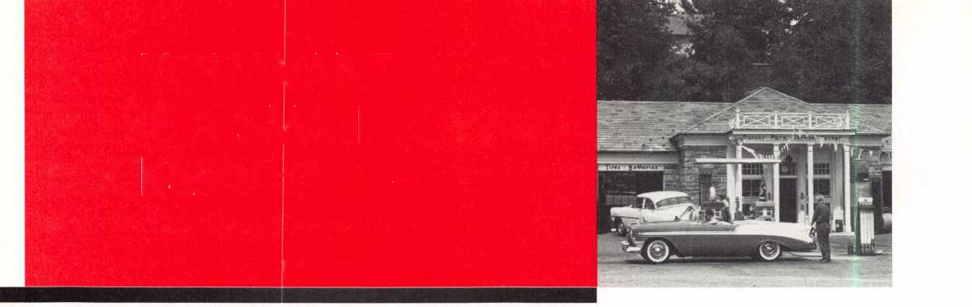

Diners Club ***International***‘

There are three reasons why people don’t accept credit cards:

Through Association Benefits **^** 1. Too expensive.

These Concerns Are Eliminated 2. The paperwork hassle.

|  |  |
| --- | --- |
| Here’s how it works: | 3. Inability to qualify. |
| • Simply swipe or enter the credit card #. |  |
| • Enter amount of sale. | No Hassle - Easy Qualifying |
| • Approval within seconds. |  |
| • Funds wired electronically into your local checking account within 48 hours. | |

Because of your association membership, nearly 100% of all retail and home based applicants

will be approved even with past credit problems.

Currently Processing Merchants Please Read

Monthly Lease To Own Set-Up Options

Special Low Discount Rate and Transaction Fee: 1.59% + 201

Plus Monthly Statement!Customer Service Fee: $10

Package A: $29.95 Terminal

Package B: $39.95 Terminal & Printer In One

Deluxe Package C: $49.95 Portable Terminal/Pnnter/Pin Pad  
Debit acess fee Ability to Accept Visa/MC “Check Cards”

SlOlmo. & ATM Cards at a FLAT 250

Totally Eliminating the 1.59 % Rate  
(All lease terms 48 months • Monthly minimum $25)

] I authorize Universal’s sales office to print and deposit a check  
in the amount of $49 (normally $125) for my application fee which  
covers initial materials, application processing, equipment warranty,

shipping & handling, programming, installation and training.

* Fill out a check, tape here above mini form and then fax.

Fax Express Mini Form Now To **1 -800-439-7773**

• nT*1 Card VaQces and-

rtypj

lycHir

orfo^^tcan,

accePt£yl

rate to

*■low.)*

Company Name.

Contact Name

Address

City

State.

Zip.

Phone

Best Time

Signature

New Account Set-up Options (Check)

Package A □

Package B CZZ3

Deluxe Package C I—I

Free Pin Pad Program For Currently Processing Merchants □

A subsidiary of Universal Savings Bank, FA.

Marketing Office *1-800-836-4295*

Universal Payment Processing Provides 24 Hour Live Customer Service.

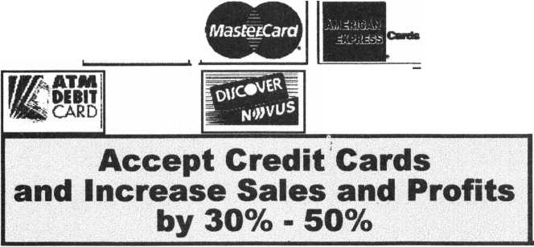

election

nominations

**What ALOA Board Positions Are Open and Where Am I Qualified to Run?**

There are currently five regional director positions open for election in addition to the position of Secretary. ALOA members now elect the directors from their own regions. Only ALOA members from a region are eligible to run for the open position(s) in that region. And only members from the nominee's region will be receiving a ballot to vote for that candidate. Members from any region are eligible to run for the Secretary's position. You must have been an ALOA member for at least three years to run.

The following vacancies will exist for the election to be held before the ALOA 2000 Convention:

**Northeast three directors**

**Northwest one director**

**South Central one director Secretary**

If you have any questions, please contact Charles Gibson at (800) 532-2562 or email [charlie@aloa.ioffice.com](mailto:charlie@aloa.ioffice.com)

On this page you will find the required nomination petition and on the following page, the nomination form.

The following is the number of signatures required for each Board

position:

**Secretary 25**

**Northeast Director 22**

**Northwest Director 3**

**South Central Director 7**

**Associate Region Director 1**



Associated Locksmiths of America, Inc.

Board of Directors Nomination Petition

Please print legibly or type. This form can be reproduced if needed.

I, the undersigned, request thatbe placed on

(name of nominee and member number)

the ballot forfor the election to be held at

(position for which individual is being nominated)

the special meeting of ALOA members to be held in 2000 or any adjournment thereof.

|  |  |  |  |
| --- | --- | --- | --- |
| 1 am eligible to vote  i | in the |  | region. |
| PRINTED NAME  2 |  | MEMBER # | SIGNATURE |
| PRINTED NAME  3 |  | MEMBER # | SIGNATURE |
| PRINTED NAME  4 |  | MEMBER # | SIGNATURE |
| PRINTED NAME  5 |  | MEMBER # | SIGNATURE |
| PRINTED NAME  6 |  | MEMBER # | SIGNATURE |
| PRINTED NAME  7 |  | MEMBER # | SIGNATURE |
| PRINTED NAME  8 |  | MEMBER # | SIGNATURE |
| PRINTED NAME  9 |  | MEMBER # | SIGNATURE |
| PRINTED NAME  10 |  | MEMBER # | SIGNATURE |
| PRINTED NAME  11 |  | MEMBER # | SIGNATURE |
| PRINTED NAME  12 |  | MEMBER # | SIGNATURE |
| PRINTED NAME  13 |  | MEMBER # | SIGNATURE |
| PRINTED NAME  14 |  | MEMBER # | SIGNATURE |
| PRINTED NAME  15 |  | MEMBER # | SIGNATURE |
| PRINTED NAME  16 |  | MEMBER # | SIGNATURE |
| PRINTED NAME  17 |  | MEMBER # | SIGNATURE |
| PRINTED NAME  18 |  | MEMBER # | SIGNATURE |
| PRINTED NAME  19 |  | MEMBER # | SIGNATURE |
| PRINTED NAME  20 |  | MEMBER # | SIGNATURE |
| PRINTED NAME  21 |  | MEMBER # | SIGNATURE |
| PRINTED NAME  22 |  | MEMBER # | SIGNATURE |
| PRINTED NAME  23 |  | MEMBER # | SIGNATURE |
| PRINTED NAME  24 |  | MEMBER # | SIGNATURE |
| PRINTED NAME  25 |  | MEMBER # | SIGNATURE |
| PRINTED NAME |  | MEMBER # | SIGNATURE |

KEYNOTES FEBRUARY 2000

14

YOUR COMMITMENT TO ALOA BOARD SERVICE

(Please read carefully and sign where indicated.)

The responsibilities of an ALOA board member include contributing a moderate amount of personal time, and a significant degree of professional guidance and expertise to the organization.

You will be expected to come to board meetings, and the annual membership meeting, prepared to sensibly discuss matters of great importance to your profession and prepared to set policy as part of a governing body. Your course of action during your tenure on the ALOA board should be guided by fairminded, constructive and achievable goals pertaining to matters of consequence for ALOA and for the industry. Your contributions are expected to benefit ALOA as a whole, taking individual member rights and concerns into account, but free of the taint of partisan politics or personal gain.

On a practical note: ALOA board members are expected to behave and dress professionally at all times, especially when actively representing the association. ALOA board members are required to participate in two board meetings per year, of three to four days in length, one each fall and spring. Board members are also asked to attend the annual convention and are required to attend the annual membership meeting. Board members may also be asked, on a voluntary basis, to represent ALOA at related local, state or regional functions, including serving in the ALOA Booth and otherwise promoting ALOA. When travel is required for a board member, expenses covered by ALOA include lodging, travel and a reasonable **per diem.** The Board has stipulated that assigned travel will be reimbursed at the lesser of the 30-day advance tourist class airfare in effect at the time of travel or the current per-mile rate for travel by personal automobile. Spouse expenses, including extra room charges, etc., are the individual's responsibility.

* * *

I have read and understand the above responsibilities of an ALOA board member, and agree to commit my time and energies as needed. I certify all of the information contained on this form and supporting documentation to be true and complete.

I can be contacted with questions at:

Address **■** Phone #

Signed: Date:

Please attach a recent photograph of yourself and retain a copy of this profile for your own files. This profile and all supporting documentation should be submitted no later than March 31, 2000.

Mail to: Nominee Profile

Secretary of the Board of Directors  
Associated Locksmiths of America  
3003 Live Oak Street  
Dallas, TX 75204-8186

REV. 02/00

15

KEYNOTES FEBRUARY 2000

LOCKSMITHING IN THE INFORMATION AGE

BY PAUL F. CHANDLER, CRL

KEYNOTES FEBRUARY 2000

16

Locksmithing is an ancient craft. Archaeologists have discovered artifacts that point to the use of locks and keys by early civilizations, handcrafted by artisans whose techniques are now forgotten. By the Middle Ages locksmiths were among the skilled craftsmen who settled in the cities and became the forerunners of our modern "middle class" (being better off than serfs, but not as well off as the land­owning gentry). Locksmiths joined guilds, which were predecessors of both our modern labor unions and of trade organi­zations like ALOA. The guild system allowed members of a trade to establish quality standards, apprenticeship programs and mutually beneficial business practices. Renaissance locksmiths needed to be both inventive and technically competent since they created locks and keys of their own designs from raw materials.

In the 19th century, our world entered the Industrial Age. Mass production of goods in factories by semi-skilled laborers eventually replaced most handcrafted products. In time, locksmiths ceased to be people who make locks and keys from raw materials. Instead, they became skilled technicians who could install, repair and otherwise service the products coming from the lock factories. By accepting and adapting to this new role, locksmiths were able to carve out a place in the Industrial Economy.

Today, we are in the transition period between the Industrial Age and the Information Age. Times of transition are always difficult to deal with. The 19th century came to be known as the Industrial Revolution. Revolutions are sometimes bloody, always disruptive. People tend to choose sides in a revolution. Some people come out on the winning side, others lose. The winners in the Industrial Revolution were the people who adapted to change and found ways to profit from the new paradigm.

How has the Information Age changed locksmithing? What changes are still in the making? How can we adapt? These are the questions that we need to ponder.

One aspect of the new paradigm that

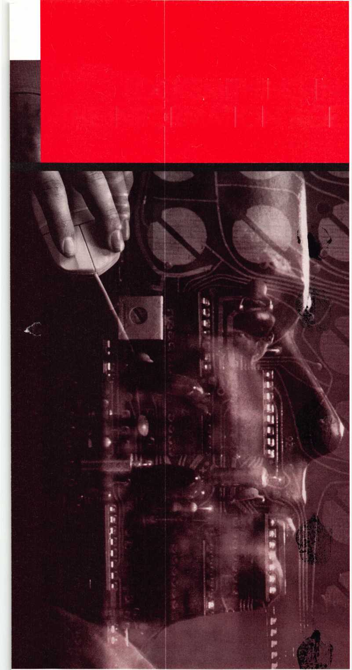

has already changed our trade is the increasing influence of law upon our choice of hardware. Industrial Age thinking was concerned with the functionality, durability and comparative cost of competing products. Today we are also concerned with code compliance, civil rights laws, negligence lawsuits and patent protection.

For example, when Medeco invented the modern high-security lock cylinder they focused on functional issues like pick- resistance, drill resistance, etc. (Industrial paradigm) Along the way, they also managed to obtain utility patents on their key blanks. In time, it became clear that it was those patents, and the unprecedented control of key blank availability resulting from those patents, which added the greatest value to the product. Soon, there were many other high-security cylinder and key manufacturers, each with their own patents. Some of the currently available high-security locking systems seem to offer no particular mechanical superiority over conventional pin tumbler locks. Neither is their security based upon manufacturing a key that cannot physically be duplicated. Given the right equipment a skilled machinist could certainly copy any key. Their value is in the intangible realm of legal protection against unauthorized key duplication.

Likewise, when President Bush signed into law the Americans With Disabilities Act, the door hardware industry was again shaken up by a legal document. Knob designs were out and levers were in. Likewise, door closers had to be easy to open and toilet stalls had to be able to close, even with a wheelchair inside. How many millions of dollars have been spent complying with just the door hardware implications of this new law?

Clearly, in the Information Age, we need to know many rules and regulations to be successful.

Information is also the driving force behind the rapid growth of access control systems for both doors and safes. We no longer simply ask our locks to keep out those who have not been granted authority to enter. Now, we wish to know who has entered, and when. We want to allow

some persons to enter, but only at certain times, or on certain days.

Mechanical locks were too limiting for the kinds of information we wanted our locking systems to possess and to store.

This led to the development of electrically operated locks. The microprocessor was adapted to manage locks according to time zones and user profiles. As digital memory has become cheaper and more compact we have been able to store more events in our audit trail buffers. More efficient use of power has permitted the invention of battery-powered access control locks for use on conventional doors as well as safe doors.

The next trend that experts in the field of access control predict is the growth of "smart card" technology, "smart cards" have tiny memory chips that can carry far more datq than conventional access control cards. A "smart card" takes much of the load off of the access control system. It may not be necessary to teach the locking system who to admit and when, that data will be resident in the cards. "Smart cards" can introduce us to locking systems we've never met before and they will treat us like old friends. But watch out! The same "smart card" will rat you out, informing the boss where you've been and when you were there.

A close cousin of electronic access control is video surveillance. This, too, is a child of the "Information Age". CCTV used to be primarily an interactive medium where living human observers watched our movements remotely on tiny grey screens and, occasionally, reacted to what we did. Increasingly, though, live monitoring is not taking place. Automated systems now record us for posterity with the results being viewed only when some particular information is needed. With improvements in video imaging, with cameras getting tinier and tinier and with recording becoming ever more efficient, it becomes that much easier to preserve the information that businesses and governments need to establish past events. Video recordings, analog or digital, are being used to establish identity, to record behavior or to provide alibis. CCTV never physically prevents a crime (although it

may deter criminal behavior by it's presence). Rather, its value is in the information we obtain which helps to solve the crime or prevent its recurrence.

The "Information Age" has also changed the way we go to the marketplace. In the old days a person entered the locksmith business by opening a shop, a fixed location where work could be taken in and business transacted. The growth of the telephone and its companion directories, has made it increasingly viable to do business without a shop, office or store. Mobile telephones have freed locksmiths from answering machines and answering services.

Today the Internet offers another medium for communicating with potential customers. Virtual stores can be created selling all types of security products without the overhead expenses of rent, inventory, utilities or employees. Just how much of the lock business will become "e-business" is yet to be seen, but this too will be part of the new paradigm.

So, the "Information Revolution" is in full swing. This doesn't mean that "Industrial Age" locksmithing is gone, or ever will be entirely gone. Just as there are still some Old World craftsmen who fashion unique locking devices and keys by hand in the finest pre-industrial tradition, there will continue to be work for "Industrial Age" locksmiths.

But the world is changing and the opportunities of the future will belong to those who understand that information is the commodity of our Age.

17

KEYNOTES

FEBRUARY 2000

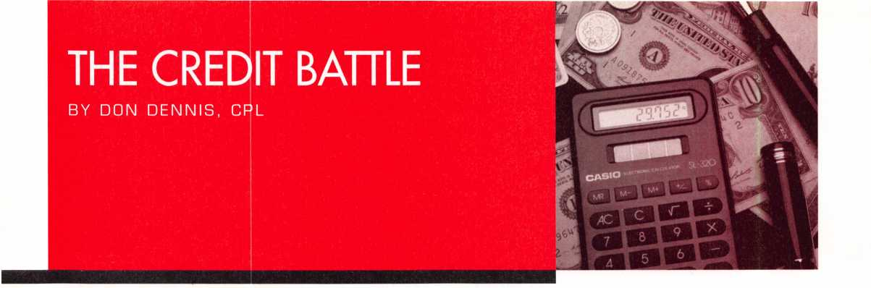

The most difficult thing that I have had to face in my many years of locksmithing has been my attitude about money. As I talk with other locksmiths, I have found that most of us have the same temperament. We spend it as fast as we can make it! If we can't make it fast enough then we borrow it and pay it back whenever.

In the beginning there was little credit. Diners Club issued the first credit card in about 1 950. So you can see that credit cards are a relatively new concept! There were mortgages and lending by banks but little else. Anyone managing to save anything would hide it under the mattress or in the refrigerator's baking soda box. In fact, a short two hundred years ago, there were still debtor prisons! How would you feel today if you were behind on MasterCard payments and you were sent to debtor's prison for three years? It was a time where bankruptcy was a very serious thing. Owing people money and not paying it back was a crime!

The lesson that has been lost in the past fifty years is that credit is a tool. Money buys the goods but credit is a tool! Do you scramble your eggs with a hammer? Would you buy a car and let it sit in the driveway while you hire a taxi to do your errands? Of course not! You have credit to use, as you would sensibly use any instrument. The concept of using someone else's money to buy goods is now taken too casually. Many times we are urged to use credit by others to make things more comfortable. We are also just plain tempted to use it to buy something that might make a job easier if we happen to get the job! It is nice having the good tools and other nice things but let me tell

you something. It is better to have the money in the bank or better still to have invested it and watch it grow without having to sweat to make it!

The essence of any relationship, whether it is personal or business, is in the expectation of gain from an exchange.

The entire relationship builds its foundation on mutual trust. This is true of a marriage, or quality products, or delivery dates, and even in the extension of credit. Since credit costs you money, it is not sensible to wonder how much you can afford to take on, but instead how much can you sensibly afford to be without! Let's pretend that you wanted a new key machine. This new machine was going to cost you $600.00. You did not have the cash or any part of the required amount so you decided that it would be a good idea to use your credit card. This card charged you an interest of 18%. You would therefore be paying $108.00 per year for the loan. If you pay the minimum amount every month and not a penny more, then this key machine has cost you $1200.00.

In very simple terms you would have to make 600 duplicate keys plus your time and key blank inventory costs to pay for this machine if you had paid cash. Using credit, you have to make 1 200 keys plus your time and inventory costs. Without considering master keying jobs and using credit, it would take some of us 6 months to a year to pay for the machine before we could begin to see a profit! In my book, this would be a bad deal.

You are probably asking me what would be a good deal! If I had a master keying job that was going to pay me $2000 to $3000 and I could obtain half payment before I began the job and half upon completion, then that would be a

good time to buy a new key machine. I would buy a new key machine on credit if I were going to loose a great deal of business in a short period of time because I didn't have it. I would pay off the debt within one to two months so as not to incur a lot of interest charges. We should always base our decisions in using credit as to its effect on our business as well as on our family. The only time to take time in paying off a debt is if you are trying to build or rebuild your credit status. You need to carry a loan for 6 months, making the proper payments in timely fashion, in order to have it reported on your credit report. Once you're in debt, there becomes only one way to successfully get out of debt. Pay it off. You pick the easiest bill to work on first and once it is paid completely off use the extra money to add to the next credit card or bill. As you do this you begin to see the end coming. Do not celebrate! Do not raise your standard of living! If you do not have a bill to pay on, then put the money into savings or invest it. Trust me! You'll need it somewhere else down the line.

It is a delight to pay my bills. Sounds strange doesn't it? I come home and in less than 30 minutes that task is done. I have the money; I pay the bills and relax. If I'm sick I can actually take the time to lay out and recuperate. That's something that you don't see a lot of in today's world. A man or woman taking the time to heal before jumping back into the game is unheard of! You're suppose to work and drop dead somewhere along the way! Respect your finances and credit as if they are your tools of the trade. Respect yourself for if you break the game stops for you and your loved ones!

KEYNOTES FEBRUARY 2000

18

membership card information

l\lext month, keep an eye out for your new membership card. It was recently mailed out along with your certificate of membership and other helpful infomation regarding ALOA.

We know many of you have been anxiously awaiting these cards as they are a vital part of your ALOA membership as well as your status as a professional locksmith.

Should you have any questions regarding your card, member number, or anything else concerning this matter, call the ALOA Office at (800) 532-2562 or write to:

ALOA

3003 Live Oak Street Dallas, TX 75204

**Keynotes** Advertisers Index

|  |  |
| --- | --- |
| Advertiser | Page |
| ALOA 2000 | BC |
| BWD | 9 |
| KSP | 19 |
| Marray Enterprises | 10 |
| MLANJ | 5 |
| ONE 800 LOCKSMITH | 20 |
| SAFETECH 2000 | IBC |
| SafeTech Reference Manual | IFC |
| Security Lock | 5 |
| Southern Lock & Hardware | 27 |
| Turn 10 | 27 |
| UPP | 13 |

INTERCHANGEABLE CORE PRODUCTS

Interchangeable with: -■

* BEST |
* arrow \ '3
* FALCON

**CONTROL**

KSP

Quality • Price KILLEEN SECURITY  
Delivery PRODUCTS

That’s what KSP is all about!

**Asfr** your wholesaler about  
our drop shipping**.**

***33 Hermon St.  
Worcester,*** IM4 ***01610  
Phone (508) 798-3200  
Fax (508) 753-2183***

19

KEYNOTES FEBRUARY 2000

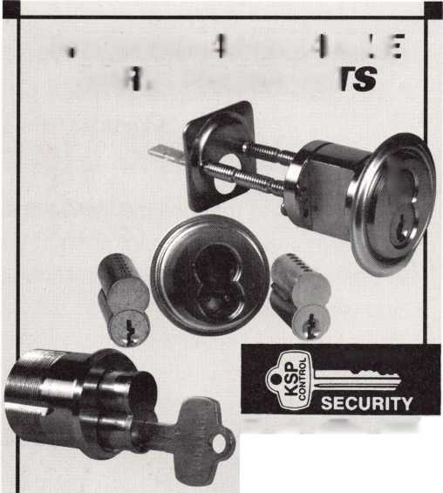

**Something for Nothing**

Last year, the ALOA Scholarship Foundation awarded 10 full convention package scholarships to ALOA '99 in Cincinnati. Ask any one of those fortunate recipients and they'll tell you it was a cost-effective and vital way of gaining even more knowledge that's conducive to their career paths.

Don't get left out of the mix this year. ALOA 2000 in Las Vegas will provide even more educational opportunities for locksmiths and security professionals. Make time NOW to complete the scholarship application form at the right.

If you've never been to an ALOA event, you don't know what you're missing. In addition to the selection of classes, there's much to see and learn throughout the showroom floor.

You too can take advantage of one of our association's most valued resources and learn more about different aspects of the trade. So what are you waiting for? The ALOA Scholarship Foundation is waiting to hear from YOU!

**BE A PART OF 1-800-LOCKSMITH!  
USE THIS NUMBER IN YOUR CITY  
& OWN THE MARKET!**

We are looking for qualified locksmiths who want to expand their business  
and develop themselves into one of the largest locksmith operations

in their city. You will be authorized to use our logo and name

and we will advertise for you on radio and television.

Interested locksmiths will be able to "secure"

as large or as small a territory as they

desire. Territories will be based

on zip codes.

KEYNOTES FEBRUARY 2000

20

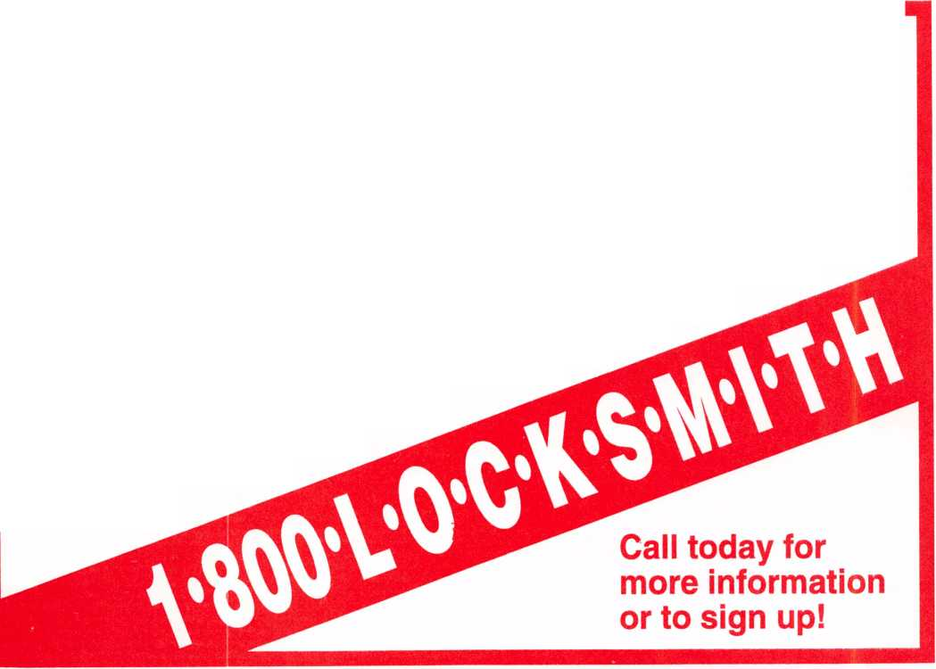

Scholarships are awarded to those individuals who demonstrate their financial need and their desire for more education in the locksmithing field. If you or someone you know fits the above criteria, please fill out the application on this page and send or fax to the ALOA Office at 3003 Live Oak St, Dallas, Texas 75204 by the due date on March 1, 2000. The fax number is (214) 827-1810. Don’t forget to include your letter stating your reason for applying, your three letters of reference and your financial information. No late or incomplete applications will be considered.

Please print or type NAME

ALOA SCHOLARSHIP FOUNDATION, INC.  
ALOA/SAVTA SCHOLARSHIP APPLICATION  
3003 Live Oak Street; Dallas TX 75204; (214) 827-1701

PRP LEVEL

HOME ADDRESS

CITY.

STATE.

ALOA/SAVTA #.

ZIP.

HOME PHONE.

DOB

PRESENT EMPLOYER.

WORK ADDRESS

POSITION

EDUCATIONAL LEVEL {YEARS) DEGREE, IF ANY_

_ WORK PHONE- FAX

CITY.

STATE.

ZIP.

□ FULL TIME □ PART TIME TAKE HOME PAY $_

LENGTH OF TIME IN LOCKSMITHING

OWNER/SUPERVISOR’S FULL NAME.

MEMBERSHIP IN TRADE ASSOCIATIONS (LIST BY NAME).  
MARITAL STATUS SPOUSE’S OCCUPATION _  
COMBINED HOUSEHOLD ADJUSTED GROSS INCOME $_

SPOUSE’S TAKE HOME PAY $_

NUMBER OF DEPENDENTS.

CLASSES DESIRED.

DATE OF CLASSES.

ORGANIZATION SPONSORING CLASSES: □ ALOA □ SAVTA □ OTHER (PLEASE NAME).

LOCATION

ALOA Scholarships are granted to selected individuals desirous of entering the locksmithing field or to selected individuals already in the locksmithing field who wish to improve their professional skills through education.

Applications for classes being taken locally must be received a minimum of 60 days prior to the date of the class, and will be reviewed as they are submitted. Scholarships for classes at the ALOA or SAVTA convention will be awarded each year at the ALOA Scholarship Foundation meeting preceding the convention and must be received by March 1 each year.

Please attach to this form a letter stating your reason for applying for a scholarship, what you plan to do with the knowledge you obtain and any other information you feel may be helpful to the scholarship board in making its decision. In addition, attach three letters of reference from individuals who have personal knowledge of your background and character. The letters should contain their names, addresses and phone numbers. It would be helpful if at least one of these references is an ALOA or SAVTA member. Also, please provide a copy of your most recent tax return.

All scholarship recipients will be required to provide a 3x5 inch photograph of themselves.

APPLICATION CHECK LIST

Only complete applications will be considered for scholarships. An application is considered incomplete unless ALL of the above requested information is received before the deadline: 60 days prior to the date of a class or March 1 for ALOA/SAVTA convention classes. Please send this application after checking off each of the below.

* I have filled in each blank on this form.
* I have written and enclosed a letter explaining my reason for applying.
* I have enclosed three letters of reference.
* I have enclosed a copy of my most recent tax return.
* I am submitting this in time to be received 60 days prior to the date of a class or by March 1 for ALOA/SAVTA convention classes.

CERTIFICATION OF APPLICANT:

I certify that the information contained herein, and all supplemental forms are complete and correct to the best of my knowledge. I further certify that if I am selected as a scholarship recipient I will use the knowledge gained for the improvement, development and advancement of the locksmithing profession.

Signature.

Date

02/00

21

KEYNOTES FEBRUARY 2000

associate

members

Associate members of the Associated Locksmiths of America (ALOA) manufacture or distribute materials or equipment, or provide services, for the security industry. Many have donated money, services and equipment to ALOA in addition to their annual dues. Their support of ALOA projects enhances overall membership benefits and we encourage our members to patronize these firms. If you know of a potential candidate for associate membership, please contact the ALOA Membership staff at (800) 532-ALOA. Associate member dues are $500 per year and entitle the payor to use the ALOA logo, and receive selected discounts on ALOA products and services.

**Legend**

Alarms: Personal, vehicle, electronic, fire, burglar, and exit

**@ Bank security equipment**

® Automotive: Lockout equipment, key chains/rings

® Builders Hardware: Door closers, furniture/decorative hardware, viewers, emergency exit devices

**® Business/Technical &**

Educational: Books, reference guides, publications, computer software

**© CCTV/Photo Imaging:**

Cameras, monitors, photo ID equipment, cables

**® Electric/Electronic Security:**

Card access control and readers, surveillance, electric/magnetic locks and strikes, keypads

**® Lock Devices:** Auto locks,

cylinders, emergency exit/entrance control, locks (various types), strikes

® Tools & Supplies: Key blanks, cutters, picks, rings/hooks, custom van/truck supplies

**9 Safes/Vaults 9 Other**

**MANUFACTURERS**

A & B Safe Corp.

171 S. Del sea Dr.

Glassboro, NJ 08028

(800) 253-1267; FAX (856) 863-1208

0 0 0 0

ASSA Inc.

10300 Foster Ave.

Brooklyn, NY 11236

(800) 235-7482; FAX (718) 257-2772

®

Abus Lock Company

3555 Holly Lane North

Plymouth, MN 55447-0507

(800) 352-2287; FAX (612) 509-9939

9

Adams Rite Manufacturing Co.

P.O. Box 1301

LaPuente, CA 91749-1301

(562) 699-0511; FAX (562) 699-5094

0 0 (0 0

Adesco Safe Manufacturing Co.

web: [www.adesco.com](http://www.adesco.com)

email: [sales@adesco.com](mailto:sales@adesco.com)

(800) 821 -6803; FAX (562) 408-6427

#

Adrian Steel Company

web: [www.adriansteel.com](http://www.adriansteel.com) Adrian, Ml 49221

(800) 677-2726; FAX (517) 265-5834

9

Alarm Lock Systems, Inc.

345 Bayview Ave.

Amityville, NY 11701

(800) ALA-LOCK; (516) 789-3383

Aiphone Intercom Systems

1700-130th Avenue, NE

Bellevue, WA 98005

(425) 455-0510; FAX (425) 455-0071

0 0 0

American Lock Co.

3400 West Exchange Road

Crete, IL 60417-2099

(708) 534-2000; FAX (708) 534-0531

® <5»

American Security Products (AMSEC)

11925 Pacific Ave.

Fontana, CA 92337-6963

(800) 423-1881; FAX (909)685-9685

0 0

Arrow Lock Company

10300 Foster Avenue Brooklyn, NY 11236 (718) 257-4700; FAX (718) 649-9097

0 0 (0 0

Auto Security Products (A. S. P.)

P.O. Box 10

Redmond, WA 98073-0010  
(425) 556-1900; FAX (425) 558-1205

010**)**

Buddy Products

1350 S. Leavitt Street Chicago, IL 60608

(800) 886-8688; FAX (312) 733-8536

0

BWD Automotive

900 Ravenwood Dr.

Selma, AL 36701

(334) 874-9001; FAX (334) 874-6011



Chicago Lock Company

10100 88th Ave.

Pleasant Prairie, Wl 53158-0069 (800) 445-3204; FAX (414) 947-7178

©

Corbin Russwin Architectural Hardware

P.O. Box 25288

Charlotte, NC 28229

(800) 543-3658; FAX (800) 447-6714

**(**0**)** (0(0(0

Curtis Industries

6140 Parkland Blvd, Ste. 300 Mayfield Heights, OH 44124-4103 (800) 555-5397

0**)** (0

DETEX

302 Detex Dr.

New Braunfels, TX 78130

(800) 729-3839; FAX (830) 620-6711



DSC Group of Companies

3301 Langstaff Road

Concord, Ontario, Canada

(905) 760-3000 ext. 2200; FAX (905) 760-3040

0 0 0 0) 0

Don-Jo Manufacturing, Inc.

P.O. Box 929 Sterling, MA 01564 (508)422-3377; FAX (508) 422-3467

0 0

Door Controls International

2362 Bishop Circle East Dexter, Ml 48130

(800)742-3634; FAX (800) 742-0410

0 0 0 0

ESP Lock Products, Inc.

375 Harvard Street Leominster, MA 01453 (978)537-6121; FAX (978) 534-9109

® 9

Folger Adam Security, Inc.

16300 W. 103rd Street Lemont, IL 60439

(630) 739-3900; FAX (630) 739-6138

9 ®

KEYNOTES FEBRUARY 2000

22

|  |  |  |
| --- | --- | --- |
| Fort Lock Corp.  3000 N. River Rd.  River Grove, IL 60171  (708) 456-1100; FAX (708) 456-9476 | LAB Security  700 Emmett St.  Bristol, CT 06010  (800) 243-8242; FAX (203) 583-7838 | ROFU International Corp.  2004-B 48th Ave.; Court E  Tacoma, WA 98424  (800) 255-7638; FAX (253) 922-1728 |
| • ••••• | • . | 0 0 0 |
| Grobet File Co. of America  750 Washington Ave.  Carlstadt, NJ 07072  (800) 962-7242; FAX (800) 243-2432 | LCN Closers (Division of Ingersol)  121 W. Railroad Ave.  Princeton, IL 61356  (815) 875-3311; FAX (815) 875-3222 | Rutherford Controls Inc.  2697 International Pkwy, Bid 5 #100  Virginia Beach, VA 23452  (757) 427-1230; FAX (757) 427-9549 |
| • | # | 0 |
| H.E.S., Inc.  2040 W. Quail Ave.  Phoenix, AZ 85027  (602) 582-4626; FAX (602) 582-4641 | La Gard, Inc.  3330 Kashiwa Street  Torrance, CA 90505  (310) 325-5670; FAX (310) 325-5615 | STRATTEC Security Corp.  3333 W. Good Hope Rd.  Milwaukee, Wl 53209  (414) 247-3333; FAX (414) 247-3329 |
| 0 0 0 | • • • | 0 0 0 |
| HPC, Inc.  3999 N. 25th Avenue  Schiller Park, IL 60176  (847) 671 -6280; FAX (847) 671 -6343 | Lucky Line Products  7890 Dunbrook Rd.  San Diego, CA 92126  (619) 549-6699; FAX (619) 549-0949 | Sargent & Greenleaf, Inc.  P.O. Box 930  Nicholasville, KY 40340-0930 (606) 885-9411; FAX (606) 887-2057 |
| 0 0 0 | • | 0 0 0 0 |
| HID Corporation  9292 Jeronimo Road  Irvine, CA 92618  (949) 568-1600; FAX (949) 568-1680 | M.A.G. Engineering & Mfg. Inc.  15261 Transistor Lane  Huntington Beach, CA 92649 (714) 891-5100; FAX (714) 892-6845 | Schlage Lock Co.  1915 Jamboree Suite 165  Colorado Springs, CO 80920 (800) 847-1864; FAX (800) 452-0663 |
| • 0 | • • • | 0 0 |
| Hongtai Lock Co* Ltd.  Jidong, Xiaolan Road, Xiolan  Zhongshan/Guangdong, China 528415 (86) 137-238-1414; FAX (86) 208-793-3856 | MARKS USA  5300 New Horizons Blvd.  Amilyville, NY 11701  (516) 225-5400; FAX (516) 225-6136 | Schwab Corporation  110 Professional Court  Lafayette, IN 47905  (765) 447-9470; FAX (765) 447-8278 |
| • • • • | • | 0 |
| llco Unican  400 Jeffreys Road  Rocky Mount, NC 27804  (252) 446-3321; FAX (252) 446-4702 | MUL-T-LOCK USA, Inc.  300-1 Route 17 South Suite A  Lodi, NJ 07644  (800) 562-3511; FAX (973) 778-4007 | Securitron Magnalock Corp.  550 Vista Blvd.  Sparks, NV 89434  (800) 624-5625; FAX (702) 355-5636 |
| 0000000 | • • • | 0 0 |
| In Out Systems, Inc.  3650-B Matte Boulevard  Brossard, Quebec J4Y-2Z2, Canada (450) 444-5949; FAX (450) 444-4856 | Master Lock Company  2600 North 32nd Street  Milwaukee, Wl 53211  (414) 444-2800; FAX (414) 449-3114 | Security Door Controls  3580 Willow Lane  Westlake Village, CA 91361 (805) 494-0622; FAX (800) 959-4732 |
| • • | 0 • | 0 |
| Intellikey  551 S. Apolo Boulevard, Suite 204  Melbourne, Florida 32901  (800) 226-0703; FAX (407) 724-0811 | Medeco Security Locks  P.O. Box 3075  Salem, VA 24153  (540)380-5000; FAX (540) 380-5010 | Security Solutions  1640 W. Hwy. 152  Mustang, OK 73064  (405) 376-1600; FAX (405) 376-6870 |
|  | • • • | 0 0 0 |
| KABA High Security Locks  RO. Box 490  Southington, CT 06489  (860) 621 -3601; FAX (860) 621 -9727 | Meilink Safe Company  111 Security Parkway  New Albany, IN 47150  (800) 634-5465; FAX (800) 896-6606 | Sentry Group  900 Linden Ave.  Rochester, NY 14625-2784  (716) 381-4900; FAX (716) 381-8559 |
| • | • | 0 |
| KEY-BAK; Div. of W. Coast Chain Mfg. Co.  1460 S. Balboa Ave.  Ontario, CA 91762  (909) 923-7800; FAX (909) 923-0024 | National Cabinet Lock  200 Old Mill Road, P. O. Box 200  Mauldin, SC 29662  (864) 297-6655; FAX (864) 297-9987 | Sully Tools Inc.  3515 Nodding Pine Ct.  Fairfax, VA 22033  (703) 689-3416; FAX (703) 787-0869 |
| • • • • | 0 | 0 0 0 |
| Knaack Manufacturing Co.  420 E. Terra Cotta Ave.  Crystal Lake, IL 60014  (800) 456-7865; FAX (815) 459-9097 | Newman Tonks  805 N Buckman St.  Shepardsville, KY 40165  (800) 826-5792; FAX (800) 777-8229 | Taymor Industries, Inc.  1586 Zephyr Ave.  Hayward, CA 94544  (800) 388-9887; FAX (800) 288-8133 |
| • | • # | 0 0 |

23

KEYNOTES FEBRUARY 2000

associate

members

Trine Products Corporation

1430 Ferris Place Bronx, NY 10461

(718) 829-4796; FAX (718) 792-9127

|g> <g g

Unelko Security Systems Ltd.

14641 N. 74th Street Scottsdale, AZ 85260 (480) 991 -7272; FAX (480) 483-7674

Videx, Inc.

1105NE Circle Blvd.

Corvallis, OR 97330

(541) 758-0521; FAX (541) 752-5285

W-Lok Corporation

675 East 16th Street, Suite 111 Holland, Ml 49423

(616) 355-4015; FAX (616) 355-4295

Weiser Lock Company

6700 Weiser Lock Blvd.

Tucson, AZ 85746

(502) 741 -6338; FAX (520) 741 -6363

(g> <0

Wilson Bohannan Company

621 Buckeye Street

Marion, OH 43301-0504

(800) 382-3639; FAX (740) 383-1653

Yale Security Inc.

P.O. Box 25288

Charlotte, NC 28229-8010

(800) 438-1951; FAX (800) 338-0965

g (g (0) <g

Zhongshan Hua Feng Lock Products

S Yongning Industrial Road, Ziaolan Zhongshan Guangdong, China

86-760 227 82 63; FAX 86-270 227 80 63

**DISTRIBUTORS**

Accredited Lock Supply Co.

P.O. Box 1442

Secaucus, NJ 07096-1442

(800) 652-2835; FAX (201) 865-5031

g g g g g g g

Ace Lock & Security Supply Co.

565 Rahway Ave.

Union, NJ 07083-6631

(800) ACE-LOCK; (800) ACE-FAX4

gggggggg

|  |  |
| --- | --- |
| ADI  263 Old Country Road  Melville, NY 11747  (516) 692-1000; FAX (516) 692-3457 | E. L. Reinhardt Co., Inc.  3250 Fanum Road  Vadnais Heights, MN 55110 (800) 328-1311; FAX (612) 481-0166 |
| g g g | g g (0 g g g |
| Akron Hardware Consultants, Inc.  2579 South Arlington Road  Akron, OH 44319  (800) 321 -9602; FAX (800) 328-6070 | Ewert Wholesale Hardware  4709 W 120th St  Alsip II 60658  (800) 451 -0200; FAX (708) 597-0881 |
| g (0 g | g g g g g |
| American Security Distribution  4411 E. La Palma  Anaheim, CA 92807  (714) 996-0791; FAX (714) 579-3508 | Fairway Supply, Inc.  2631 Lombardy Lane  Dallas, TX 75220  (214)350-0021; FAX (214) 352-4299 |
| g g g g g g g | g g g (0 g g g |
| Andrews Wholesale Lock Supply  544 S. 9th St.  Lebanon, PA 17042-6608  (717) 272-7422; FAX (717) 274-8679 | Foley-Belsaw Company  6301 Equitable Road  Kansas City, MO 64120 (800)821-3452; FAX (816) 483-5010 |
| g | g g g g |
| Boyle & Chase Inc.  P. O. Box 74  Accord, MA 02018-0074  (800) 325-2530; FAX (800) 205-3500 | Fried Brothers, Inc.  467 N. 7th St.  Philadelphia, PA 19123  (800) 523-2924; FAX (800) 541 -3489 |
| g (0 g | gggggggggg |
| Clark Security Products, Inc.  4775 Viewridge Ave.  San Diego, CA 92123-1641  (800) 854-2088; FAX (619) 974-5284 | HS&S Wholesale Distributors  12915 West 8 Mile Road  Detroit, Ml 48235  (800) 521-2202; FAX (313) 342-7580 |
| gggggggggg | g g g g g g g |
| Cook's Building Specialties  2441 Menaul Blvd. NE; P.O. Box 37320  Albuquerque, NM 87176-7320 (505)883-5701; FAX (505) 883-5704 | Hans Johnsen Company  8901 Chancellor Row  Dallas, TX 75247  (214) 879-1550; FAX (214) 879-1530 |
| g g g (0 g g | gggggggg |
| DiMark International  3117 Liberator St., Unit A  Santa Maria, CA 93455  (800) 235-2435; FAX (805) 928-8034 | Hardware Agencies, Ltd.  1220 Dundas Street East  Toronto, ON M4M 1 S3  (416) 462-1921; FAX (414) 462-1922 |
| g g g g | gggggggg |
| Dire's Lock & Key Co.  2201 Broadway  Denver, CO 80205  (303) 294-0176; FAX (303) 294-0198 | Hardware Suppliers of America  P.O. Box 2208  Winterville, NC 28590  (800) 334-5625; FAX (800) 334-5635 |
| ggggggggggg | g g |
| Direct Security Supply, Inc.  36 Lincoln Street  Boston, MA 02135  (800) 252-5757; FAX (800) 452-8600 | IDN, Inc.  1000 S. Main, Suite 280  Grapevine, TX 76051  (817) 421 -5470; FAX (817) 421 -5468 |
| g g g g g (0) g | gggggggggg |
| Doyle Lock Supply  2211 W. River Road N.  Minneapolis, MN 55411  (800) 333-6953; FAX (612) 521-0166 | Intermountain Lock & Supply Co  3106 South Main Street  Salt Lake City, Utah 84115  (800) 453-5386; FAX (801) 485-7205 |
| ggggggggggg | gggggggggg |
| Dugmore & Duncan Inc.  30 Pond Park Rd.  Hingham, MA 02043  (888) 384-6673; FAX (888) 329-3846 | JLM Wholesale, Inc.  3095 Mullins Ct  Oxford, Ml 48371-1643  (800) 522-2940; FAX (800) 782-1160 |
| g g g (0 g (5 g | g g g |

KEYNOTES FEBRUARY 2000

24

SERVICE

Jo-Van Distributors Inc.

929 Warden Ave.

Scarborough, Ontario Ml L 4C6 (416) 752-7249; FAX (416) 752-3845

Sentry Security Fasteners

8109 N. University Peoria, IL61615

(309) 693-2800; FAX (309) 693-2872

|  |  |  |
| --- | --- | --- |
| Lockmasters, Inc.  5085 Danville Road  Nicholasville KY, 40356  (800) 654-0637; FAX (606) 885-7093 | Southern Lock and Supply Co.  Box 1980, 10910 Endeavor Way  Pinellas Park, FL 33780  (800) 237-2875; FAX: (800) 447-2299 | 1 -(800) Tow Truck, Inc.  190 Main Street  Hackensack, NJ 07601  (800) 835-4187; FAX (800) 835-4189 |
| • • • • | • •••••••• |  |
| Locks Company  2050 N.E. 151 St.  N. Miami, FL 33162  (800) 288-0801; FAX (305) 949-3619 | Stone & Berg Wholesale  99 Stafford Street  Worcester, AAA 01603  (800) 225-7405; FAX (800) 535-5625 | Alarm Monitoring Service, Inc.  5021 Fairfield St.  Metairie, LA 70006  (504) 454-2163; (504) 456-8737 |
| • •••••• | •••••••••• | • |
| The Locksmith Store Inc.  1229 E Algonquin Rd. Suite E  Arlington Heights, IL 60005  (847) 364-5111; FAX (847) 364-5125 | Strauss Safe & Lock Company  1801 Second Avenue  Des Moines, IA 50314 (515)288-9571; FAX: (515) 288-9752 | Allstate Insurance Company  2775 Sanders Road, Suite A5  Northbrook, IL 60062  (847) 402-8196; FAX (847) 326-7509 |
| • • • • | • ••••• | • |
| M. Zion Company  69 Reade Street, 4lh Floor  New York, NY 10007  (212) 349-8677; FAX (212) 964-0495 | Tanner Bolt & Nut Corporation  4302 Glenwood Road  Brooklyn, NY 11210  (718) 434-4502; FAX (718) 434-3215 | Diamond Software  2952 N. Expressway  Griffin, GA 30223  (770) 227-7650; FAX (770) 227-1699 |
| • •••••• | • | • |
| McDonald-DASH Locksmith Supply  5767 E. Shelby Dr.  Memphis, TN 38141  (800) 238-7541; FAX (901) 366-0005 | Timemaster, Inc.  127 SE 29th Street  Topeka, KS 66605  (785) 232-8705; FAX (800) 798-8463 | Locksmith Publishing Corp.  850 Busse Hwy.  Park Ridge, IL 60068  (847) 692-5940; FAX (847)692-4604 |
| eeeeeeee | • •••••• | • |
| McManus Locksmith Supply, Inc.  P.O. Box 9231, 1309 Central Ave.  Charlotte, NC 28299  (702) 333-9112; FAX (704) 332-8664 | Top Notch Distributors, Inc.  3151 Goni Rd.  Carson City, NV 89706-7922 (800) 722-4210; FAX (800) 248-3620 | The National Locksmith Magazine  1533 Burgundy Parkway  Streamwood, IL 60107  (630) 837-2044; FAX (630) 837-1210 |
| • ••••• | • • • | • |
| McMaster-Carr Supply Company  600 County Line Rd,  Elmhurst, IL 60126-2081  (630) 833-0300; FAX (630) 834-9427 | Turn 10  P.O.Box 746  Marietta, OH m45750  (800) 848-9790; FAX (800) 391 -4553 | Pine Technical College  1000 4th Street  Pine City, MN 55063 (800)521-7463; FAX (320) 629-7603 |
| • ••••• | • • | • |

|  |  |
| --- | --- |
| Monaco Lock Co.  339-345 Newark Ave.  Jersey City, NJ 07302  (800) 526-6094; FAX (800) 845-LOCK  • • • | U.S. Lock Corporation  77 Rodeo Drive  Brentwood, NY 11717  (800) 925-5000; FAX (800) 338-5625  • • • • • |
| Securite.com | Webster Safe & Lock Company, Inc. |
| 4775 Viewridge Avenue | 3020 Millbranch |
| San Diego, CA 92123 | Memphis, TN 38116 |
| (800) 241 -3930; FAX (619) 974-5269 | (901) 332-2911; FAX (901) 332-2878 |
| • • • | • •••••• |

Omaha Wholesale Hardware

1201 Pacific Street, PO Box 3628 Omaha, NE 68108 (800) 238-4566

Security Lock Distributors

40 A Street

Needham Heights, AAA 02194 (800) 847-5625; FAX (800) 878-6400



25

KEYNOTES

FEBRUARY 2000

classifieds

**Classified Advertising Policy**

Classified advertising space is provided free of charge to ALOA members, and for a fee of $.60 per word, $15 minimum for non-members. Classified ads may be used to advertise used merchandise and overstocked items for sale, "wanted to buy" items, business opportunities, employment opportunities/positions wanted and the like. Members or non-members wishing to advertise services or new merchandise for sale may purchase a "Commercial Classified Ad," for a fee of $1.30 per word, with a minimum of $40. Each ad will run for two issues. For blind boxes there is a $5 charge to members and non-members. All ads must be submitted in writing to the ALOA office by the fifteenth of the month, two months prior to issue date. Send to: Keynotes Classifieds, 3003 Live Oak St., Dallas TX 75204-6186. ALOA reserves the right to refuse any classified advertisement that it deems inappropriate according to the stated purpose of the classified advertising section.

**EMPLOYMENT** Locksmith Wanted

l/F/3: One locksmith wanted to fill positions in Missoula, Mont. We need an outside and an inside service representative. We have two vans and a storefront. Prefer two years of experience must be willing to relocate. Salary DOE plus commission possible, paid vacation and the opportunity for advancement.

Call Peter:

(406) 542-2472 (406) 542-3221 fax

Professionals Wanted

l/F/3: Look into your future now! If you are experienced, intelligent and desire a secure future, come join our team. We are a full service commercial /residential security service (locks, keys, safes, CCTV, access control, door related hardware). We offer the following: a sign on bonus, top wages, company vehicle, 401 K, paid vacation, paid holidays, new uniforms, cross training and job satisfaction. We are looking for the best techs, who are ready to be treated and compensated as professionals.

Call or send resume to:

Ross Mesnick

Bass Security Services, Inc.

26701 Richmond Rd.

Bedford Hts., OH 44146 (216) 755-1200 ext. 128 (216)755-1220 fax

Commercial Locksmith Wanted

12/F/3: One of Atlanta's largest and most prestigious commercial mechanical security companies is seeking an experienced, highly motivated self-starting technician who is capable of handling and carrying himself well and the ability to service clients in a corporate environment. Relocation compensation and signing bonus is an option for the right individual. Send resume to:

Rhonda Cheek, VP Operations

All State Access Lock and Security Company

2274 Atlanta Road

Smyrna, CA 30080

(770) 434-9966

Experienced Technician Wanted

12/F/3: Join a fast growing 23 year old firm in America's #1 place to live, Nashua, New Hampshire. Top wages in area paid to career oriented professional with excellent benefit package.

New Hampshire Safe and Lock 345 Amherst Street Nashua, NH 03063 (800) 838-0152 (603) 889-2849 fax nhsafelock@aol. com

Experienced Service &

Shop Technicians Needed

12/F/3: Due to continued growth, we are looking for outside and inside service technicians. Our company has been in business since 1880 and is located in the beautiful Pacific Northwest. Argens Incorporated is a multi dimensional company. We target commercial and industrial accounts of all sizes. Our company specializes in general locksmithing, electronic security (card access & CCTV), door servicing and gate systems. We are an employee driven company with excellent pay, benefits, sale incentives and can offer advancement as our growth continues. Send resume to:

Jim King

Argens Incorporated 84 S Main Street Seattle, WA 98104 (206) 623-2662 (206) 622-5056 fax argens@w-link. net

Experienced Technician Wanted

12/F/3: Family owned business since 1911, serving Knoxville and surrounding areas in East Tennessee are in need of experienced commercial, industrial and residential technicians. Must supply background check, work and personal references, have a clean driving record, no felonies, able to work as a team player, neat, honest and good communi­cation skills. Salary with monthly and yearly bonuses. Insurance and retirement plan after 90 day trial, paid vacation and sick days after one year. Send resume and cover letter to:

Attn: William M. Peters Jr., CRL F. M. George Safe & Lock Co., Inc.

PO Box 3398

Knoxville, TN 37927-3398

Service Tech Wanted

12/3/F: Established locksmith company is seeking service technician with commercial experience. Must be professional and ambitious. Qualified technician can earn up to $18 per hour. Medical insurance, vacation, plus other benefits. Submit resume.

(562) 464-0333 (562) 464-0335 fax

Automotive Locksmith Wanted

12/F/3: Relocate to South Florida and throw away your deadbolts and 3 keys for a dollar. We run over 300 calls per week. You must own a truck with tools and code equipment to cut all foreign and domestic keys. You can earn $800 to $1500 per week. Please, if no truck or tools—no calls.

South Florida Lock & Safe (800) 928-2926

KEYNOTES

FEBRUARY 2000

26

Locksmith

ll/F/3: Company doing services for financial institutions has a great opportunity for a general- purpose locksmith to service the Seattle area. Must have vault and safe experience. Competitive salary, benefits and company vehicle provided. Clean driving record required. Fax resume to:

Attn. Grant Driskill (503) 670-0743

**BUSINESSES FOR SALE** Business For Sale

12/P/3: Established locksmith business for sale in western Missouri. Recently assessed at 160K. Still growing. Industrial, institutional accounts as well as automotive, residential, bank and commercial accounts. Access control experience a plus. Master keying knowledge a must. Safe and safe deposit box service and repair experience helpful. Equipped van negotiable. Good location in growing community. Asking 160K. Owners seeking change. Only serious inquiries please. Reply to:

Keynotes Classifieds 3003 Live Oak Street Dallas, TX 75204 (214) 827-1701

Mobile Service For Sale

1/F/3: For sale. Tampa Florida's Foremost mobile locksmith service. Sale includes accounts, equipment, merchandise and 1996 van.

Call: (813) 985-2028

**WANTED TO BUY/SELL** Keyblanks Wanted

l/F/3: Old key blanks, Hurd, Briggs-Stratton, Yale, etc. I will pay $1 each. Send me a list of what you have.

Douglas Vogel 4779 Meadow Lark Lane Dexter, Ml 48130

Wanted To Buy

1 l/F/3: Wanted used 1200 HPC Machine Call: (301) 627-5876

Code Machine Wanted

l/F/3: I am searching for an ITL 950 Code Machine. If you have one or know of someone interested in selling their machine, please contact me.

Contact:

William Weber East Side Locksmith (313) 881-0280 wdweber@home. com

For Sale

12/F/3: 30 used Corbin ML2267 knob mortise locks. Abloy equipment, Key machine, deadbolts, cylinders and keys. Make offer.

A-l Lock & Key (305) 559-9999

**TURfllO**

WHOLESALE SERVICE

**800-848-9790**

**One Call  
Gets You...**

**Amsec**

**Gardall**

**•**

**Hayman**

**Meflink**

**Victor**

**•**

**Winchester**

«

**Plus Free Delivery  
From America's  
Largest Inventory  
of Safes.**

**The Southern lock**

**learning Eh**

*EXPO Dates:*

' *Saturday & Sunday, March 18 & 19, 2000*

'"■"*91

You've attended dozens of trade shows; and its getting hard to tell one show from the next. Well, now its time for some­thing completely different...

... Embark on an educational journey at the Southern Lock Learning Expo 2000. Expand your technical expertise at one or more of the classes and seminars at our show. Learn first hand from the manufacturers’ represen­tatives about the latest technological advances in our industry. Educational seminars, certification classes, and a whole lot more!

Don't be left behind, the future of your business depends upon your ability to service the new and changing technologies on the market today. Plan now to attend this innovative and enlightening event. Call for more information or visit our web site.

Toll Free Phone Numbers

* Main Florida Warehouse

800-282-2837

* Fax: 800-447-2299
* Atlanta Warehouse: 877-217-9396
* Charlotte Warehouse: 888-571-9145
* South Florida Warehouse: 888-780-6071

**^^PJTHERN**

C/jOCK

**& SUPPLY CO.**

L

P.O. Box 1980;

Pinellas Park, FL 33780-1980

e-mail: [sales@southernlock.com](mailto:sales@southernlock.com)  
[www.southemlock.com](http://www.southemlock.com)

Serving the Industry Since 1946.

27

KEYNOTES FEBRUARY 2000

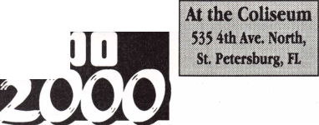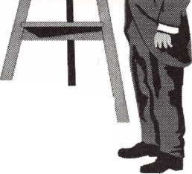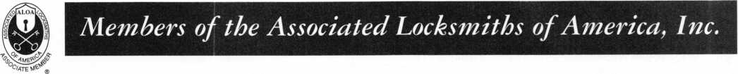

The Need for Accident & Health Coverage

Every six minutes, an accidental death occurs in the United States. In one day, over 250 people will die in an accident.' The increasing number of accidents that have given rise to these statistics make having accident insurance a necessity.

Accidental Death and Dismemberment Insurance, Your Best Choice!

The Accident and Health Division of the member companies of American International Group,

Inc. (AIG) can help you protect yourself as a member of Associated Locksmiths of America from the costly effects of a serious accident. A serious injury or the accidental death of a wage earner can be devastating. Home mortgage payments, college education costs, retirement savings, and childcare may all be jeopardized if there isn’t enough resources to help provide the security that you need. With Accidental Death and Dismemberment Insurance you can have the financial security that you need at an economical cost.

Our Accidental Death and Dismemberment coverage meets your needs by offering members of the Associated Locksmiths of America a policy with stand-alone AD&D Benefits. We provide 24-hour, worldwide coverage and many optional benefit enhancements.

Associated Locksmiths of America has been able to customize the policies for their members with many benefits and services including:

The AIG Life Companies (U.S.), members of American International Group, Inc. (AIG), include AIG Life Insurance Company (AIG Life), Wilmington, DE: and American International Life Assurance Company of New York (AILife), New York, NY. AIG, our parent company, is the leading U.S.-based international insurance organization.

* Accidental Death
* Paralysis
* Accidental Dismemberment
* Exposure & Disappearance

AIG Life and AILife have each earned the highest possible rating from three principal rating companies:

• AAA Extremely Strong by Standard & Poor’s* (insurer financial strength and

claims-paying abilities);

* Aaa Exceptional by Moody’s* (financial strength); and
* A + + Superior by A.M. Best (operating performace and financial strength).

*Rated with the support of American International Group, Inc.

Associated Locksmiths of America, Inc.  
3003 Live Oak Street  
Dallas, TX 73204

National Safety Council Accident Facts, 1997



The AIG Life Companies (U.S.)

KEYNOTES FEBRUARY 2000

28

**Heavy Metal.**

Safe and vault technicians are not strangers to th concept of how to make large metal objects rock and roll. So what better place to hold the last safe and vault trade show of the millennium than The Steel City-Birmingham, Alabama?

From manufacturers' seminars, to education, to demonstrations and more, SAFETECH2000 is your best opportunity to prepare yourself for your future.

While you're there you can enjoy the city known for its industriousness, as well as good ol' Southern hospitality. Tour the Sloss Furnaces, the Mercedes Benz factory or any of a number of museums. You can also explore the richly wooded foothills and mysterious caverns of the Appalachian Mountains.

Join us May 1 through 6 and we're sure you'll agree-Birmingham, and SAFETECH2000 rock!

For more information call

214.827.7233,

or visit our website at

[www.savta.org](http://www.savta.org)



**SAFETECH2000**WE'VE GOT THE WORKS

To navigate your locksmithing enterprise into the next millennium you need the latest training, product information, and tools.

You can explore the entire locksmithing universe at one great show—ALOA 2000 in Las Vegas, Nevada.

can also beam aboard the Las Vegas Hilton's newest attraction— Star Trek: The Experience. For more information visit our website at <http://www.aloa.org/> and plan to boldly go to ALOA 2000.